JAX-RS - @DELETE
此例顯示如何使用 @DELETE 註釋處理 HTTP 方法 DELETE 請求。
程式架構:
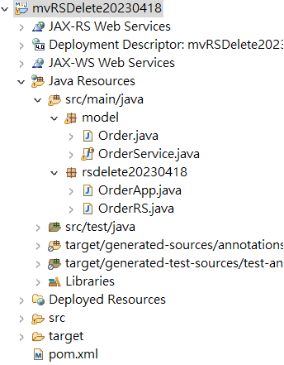
Rest pom.xml
<dependency>
<groupId>org.glassfish.jersey.bundles</groupId>
<artifactId>jaxrs-ri</artifactId>
<version>2.35</version>
</dependency>

<dependency>
<groupId>javax.xml.bind</groupId>
<artifactId>jaxb-api</artifactId>
<version>2.3.0</version>
</dependency>
<dependency>
<groupId>com.sun.xml.bind</groupId>
<artifactId>jaxb-core</artifactId>
<version>2.3.0</version>
</dependency>
<dependency>
<groupId>com.sun.xml.bind</groupId>
<artifactId>jaxb-impl</artifactId>
<version>2.3.0</version>
</dependency>
Model:

import java.util.Date;

public class Order {
private int id;
private String item;
private int qty;
private Date orderDate;

public Order() {
}

public int getId() {
return id;
}

public void setId(int id) {
this.id = id;
}

public String getItem() {
return item;
}

public void setItem(String item) {
this.item = item;
}

public int getQty() {
return qty;
}

public void setQty(int qty) {
this.qty = qty;
}

public Date getOrderDate() {
return orderDate;
}

public void setOrderDate(Date orderDate) {
this.orderDate = orderDate;
}

@Override
public String toString() {
return "Order{" +
"id=" + id +
", item='" + item + '\'' +
", qty=" + qty +
", orderDate=" + orderDate +
'}';
}
}

特殊的OrderData Service Enum程式:

import java.time.Instant;
import java.time.OffsetDateTime;
import java.time.Period;
import java.util.*;

public enum OrderService {
Instance;
private Map<Integer, Order> orders = new HashMap<>();

private OrderService() {
Instant instant = OffsetDateTime.now().toInstant();
for (int i = 1; i <= 5; i++) {
Order order = new Order();
order.setId(i);
order.setItem("item " + i);
order.setQty((int) (1 + Math.random() * 100));
long millis = instant.minus(Period.ofDays(i))
.toEpochMilli();
order.setOrderDate(new Date(millis));
orders.put(i, order);
}
}

public Collection<Order> getAllOrders() {
return new ArrayList<>(orders.values());
}

public boolean deleteOrderById(int orderId) {
return orders.remove(orderId) != null;
}

public Order getOrderById(int id) {
return orders.get(id);
}
}

Order Rest服務程式:
import javax.ws.rs.ApplicationPath;
import javax.ws.rs.core.Application;

@ApplicationPath("api")
public class OrderApp extends Application {
}

import javax.ws.rs.*;
import javax.ws.rs.core.MediaType;
import java.util.Collection;
import model.*;

@Path("/orders")
public class OrderRS {

@GET
@Produces(MediaType.APPLICATION_JSON)
public Collection<Order> getOrders() {
return OrderService.Instance.getAllOrders();
}

@DELETE
@Path("/{id}")
@Produces(MediaType.TEXT_PLAIN)
public boolean deleteOrderById(@PathParam("id") int id) {
return OrderService.Instance.deleteOrderById(id);
}

@GET
@Path("/{id}")
@Produces(MediaType.APPLICATION_JSON)
public Order getOrderById(@PathParam("id") int id) {
return OrderService.Instance.getOrderById(id);
}
}

PostMan測試:

